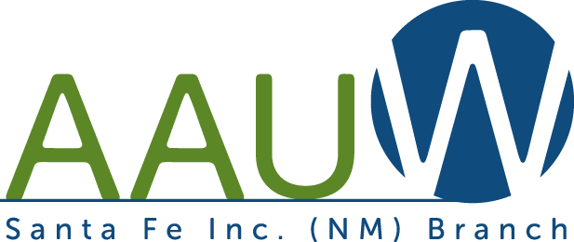
Save the date!
Saturday, September 18, 2021
AAUW Member Ice Cream Social
1 – 3 PM
Estancia Primera Clubhouse
450 Ave Primera S, Santa Fe

Bring a potential new member or an AAUW friend. To have an invitation mailed to your friend, or if you have questions, contact:
Cate Corgill – Membership Chair
650-248-0457
ccorgill@gmail.com
More information, including directions, will be sent out closer to the social.

